<Figure size 1000x800 with 0 Axes>
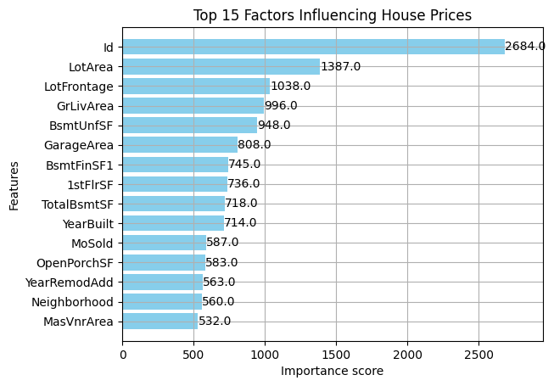
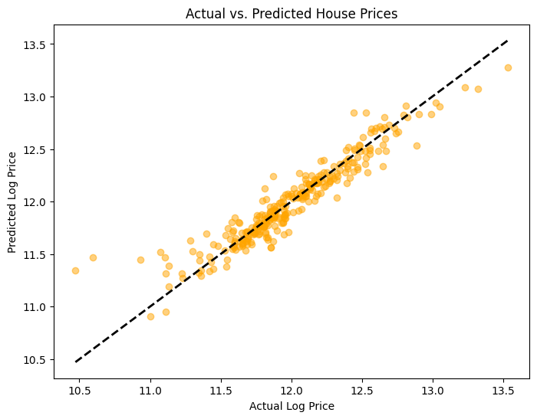
https://hybridisable-ernest-aristocratically.ngrok-free.dev/

